The fourth Forteca International Film Festival

- CETINJE, Montenegro
Fakultet dramskih umetnosti Cetinje, Multumedijalna sala 25. maja
i Lipska pećina DRIVE IN CINEMA, 28. i 29. maja, veliki plato isperd Lipske pećine,

ONLINE SCREENINGS
between 25th May – 8th June 2021,

Posljednja filmska ostvarenja Švedske i Nordijskih zemalja na
4. Forteca medjunarodnom filmskom festivalu Perast,

na Fakultetu dramskih umetnosti Cetinje - Multumedijalna sala
i na velikom platou ispred Lipskoj pećini,
u saradnji sa Filmskim centrum Crne Gore, Turističkom orgaizacijom Cetinje i ambasadom Švedske u Crnoj Gori

25. maj, Fakultet dramskih umetnosti Cetinje, Multumedijalna sala
19.30.
SVEČANO OTVARANJE
20.00
Pool, Sweden, 2020, drama, 95’, Swedish, French, English with English subtitles ONLINE PANEL S AUTOROM rediteljem Anderš Lenberg (Anders Lennberg)

28. maj, Lipska pećina, DRIVE IN CINEMA (veliki plato ispred Lipske pećine)
19.30
Charter, Sweden, 2020, drama, 94’, Swedish with English subtitles
21.10
Goliat/Goliath, Sweden, 2018, crime, drama, 88’, Swedish with Montenegrin subtitles

29. maj, Lipska pećina, DRIVE IN CINEMA (veliki plato ispred Lipske pećine)
19.30
Mannen som lekte med elden/The Man Who Played with Fire, Sweden, 2018, documentary-drama, 99’, Swedish with English subtitles
21.10
The Perfect Patient /Quick, Sweden, 2019, crime, drama, thriller, 132’, Swedish with English subtitles

PROGRAM WITH THE MOVIES::::::::::::::::::::::::::::::::::::::::::::::::: 4th FIFFP, CETINJE

Charter, Sweden, 2020, drama, 94’, Swedish with English subtitles

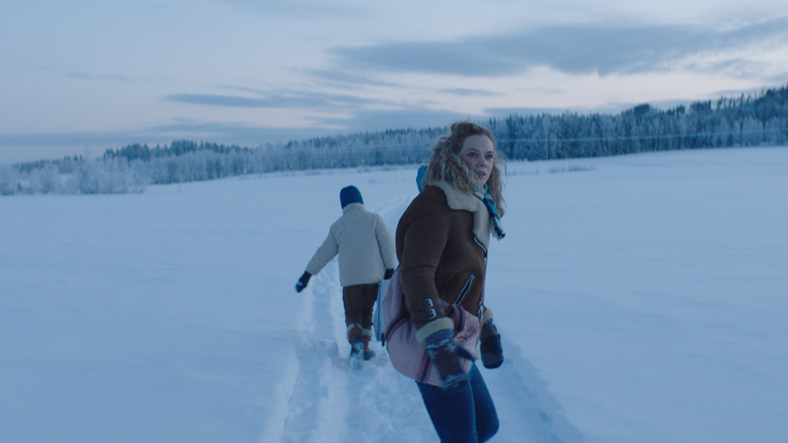

After a divorce, Alice hasn't seen her children in two months as she awaits a custody verdict. When her son calls her in the middle of the night, Alice takes action, abducting the children on an illicit charter trip to the Canary Islands.

Director: Amanda Kernell
Production company: Det Danske Filminstitut, Eurimages, Film i Västerbotten
Cast: Ane Dahl Torp, Sverrir Gudnason, Troy Lundkvist
Goliat/Goliath, Sweden, 2018, crime, drama, 88’, Swedish with English subtitles

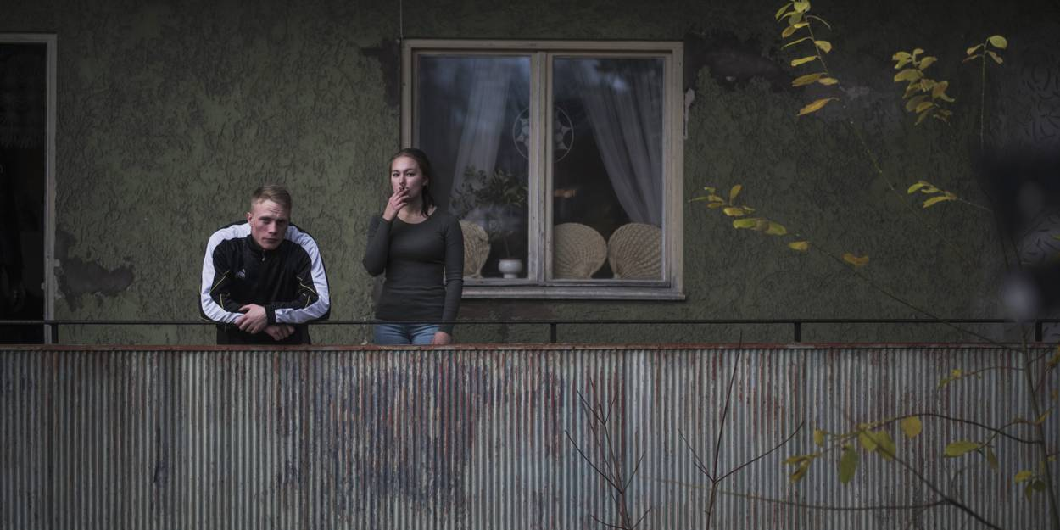

Goliat is set in a small industrial town somewhere in Sweden. When Roland is sentenced to prison, his son, 17-year old Kimmie, is expected to provide for the family by taking over his dad's criminal business. This is a task he's not ready for. The film's depicting a boy's brutal entry into adult life and examines aspects of social heritage and patriarchal structures, at a time when the welfare is declining and Sweden is changing.

Director: Peter Grönlund
Production company: B-Reel Films
Cast: Sampo Sarkola, Joakim Sällquist, Cedomir Djordjevic
The Perfect Patient /Quick, Sweden, 2019, crime, drama, thriller, 132’, Swedish with English subtitles

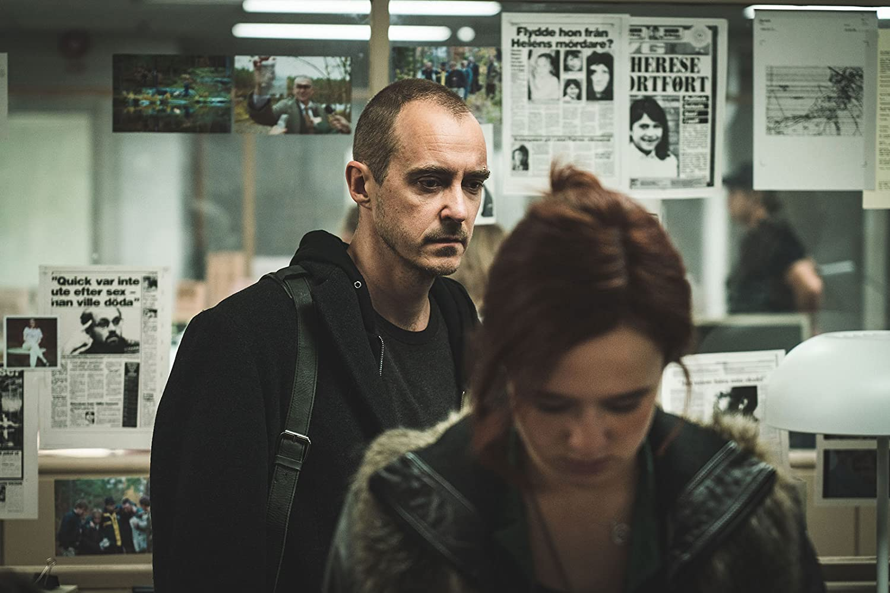

The captivating story of Sweden's greatest judicial scandal ever, about one man who sacrificed everything in his hunt for the truth.

Director: Mikael Håfström
Production company: Brain Academy, Film i Väst, Nordisk Film
Cast: Jonas Karlsson, David Dencik, Alba August
Producer: Helena Danielsson

Mannen som lekte med elden/The Man Who Played with Fire, Sweden, 2018, documentary-drama, 99’, Swedish with English subtitles

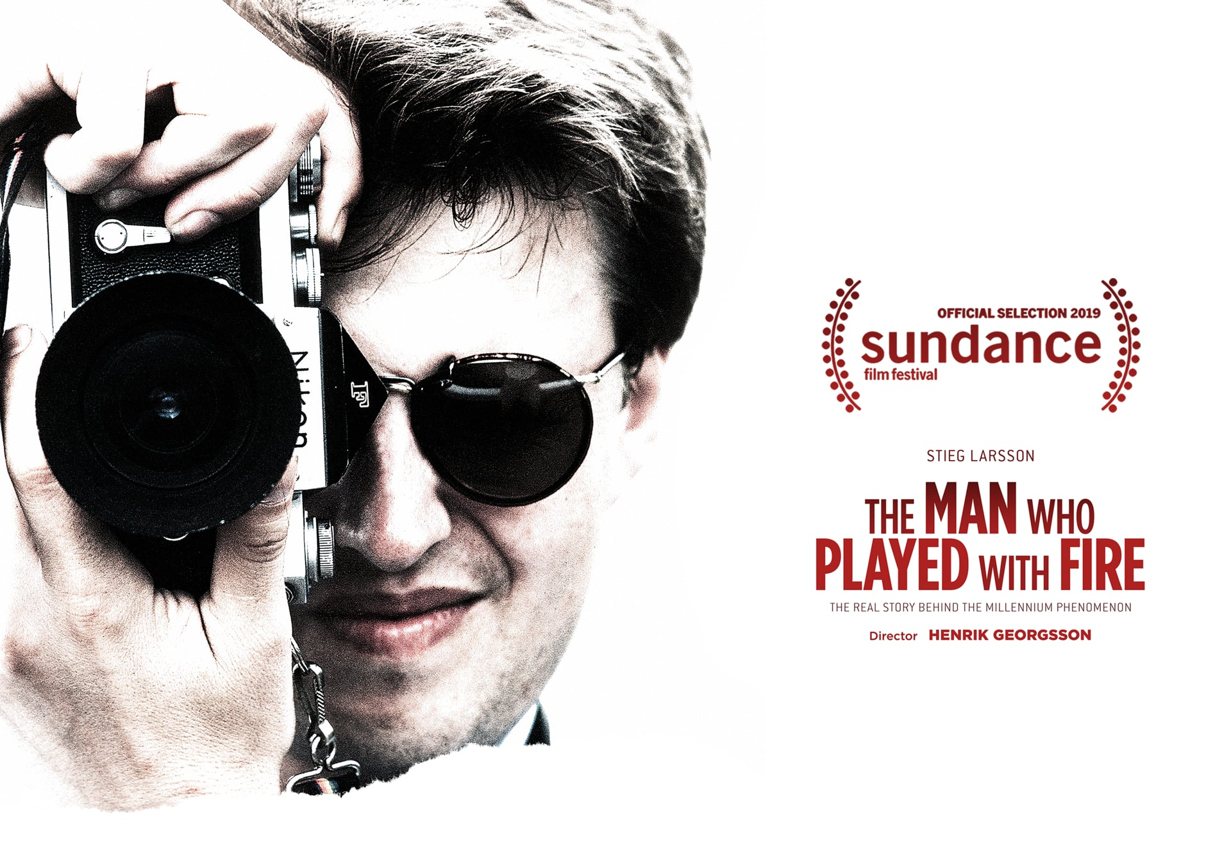

A documentary about the Millenium-trilogy author Stieg Larsson and pioneering work of fighting with extremists and neo_Nazis, an obsession with fatal consequences.

Director: Henrik Georgsson
Production company: B-Reel Films, C More Entertainment
Cast: Emil Almén, Johan Eriksson, Magnus Höqqvist

Pool, Sweden, 2020, drama, 95’, Swedish, French, English with English subtitles

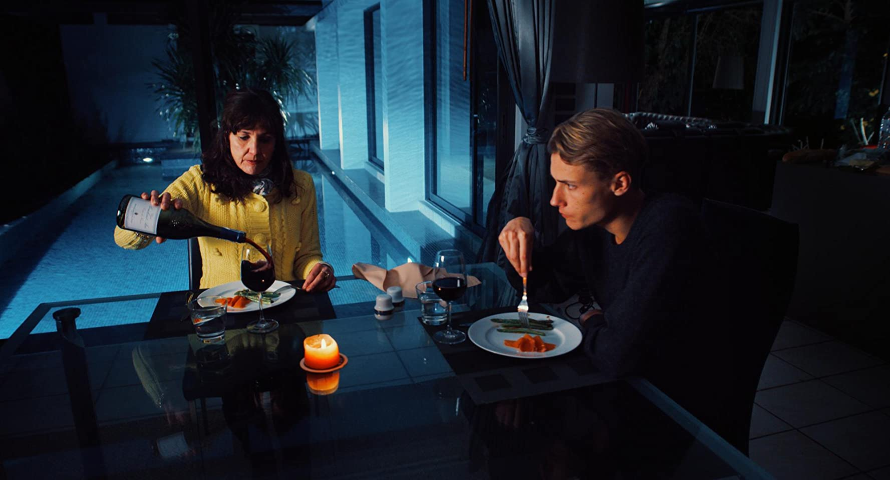

24 year old Johan spends his days in Nice on the French Riviera, supported by an aging ex-actress. Days go by between her house, the beaches and the apartment of his friend Kurt. A life in leisure and luxury.But memories of Johan's teenage years are haunting him. A strong sense of threat is growing stronger and stronger. Desire and fear are acted out by the controlled but helpless people in this seemingly perfect and glamorous world.

Director: Anders Lennberg
Production company: Pool Productions AB
Cast: David Asavanond, Moa Garpendal, Niclas Gillis

OTVARANJE, Fakultet dramskih umetnosti Cetinje, Multumedijalna sala
25. maja
LIVE SCREENINGS, Lipska pećina DRIVE IN CINEMA
28. i 29 maj od 19.30
MJESTO Lipa Dobrska bb, Cetinje
Veliki plato isped Lipske pećine

SLOBODAN ULAZ.
REZERVACIJE MJESTA SU OBAVEZNE.
Kontakt telefoni: +382 (0) 67 00 30 40
U skladu sa preporukama NKT Crne Gore broja mjesta je ograničen.

FIFFP CETINJE on ONLINE!
Filmovi ce tokom Festivala biti dostupni ONLINE izmedju 25. maja – 8 juna.
Potrebno je da se prijavite na pass@fiffp.com radi unosa podataka za otvaranje digitalne platforme. Označite mejl sa: ONLINE SCREENING i vase ime.
Nasi saradnici u Nordijskim zemljama: Swedish Film Institute, Swedish Institute, Norwegian Film institute, M.A.M.M.A. production, Justin Theatre Production, ABF Stockholm, Stockholm City, Balkan Nordic Film Festival in Stockholm, Film Centres in Balkan and internationally, SNOWE.se
Lokalne organizacije: Fakultet dramskih umetnosti Cetinje, TOC – Turistička organizacija Cetinje, Lipska pećina Cetinje, Ambasada Švedske u Crnoj Gori,
JU Kulturni centar “Nikola Đurković” Kotor, Turistička organizacija Kotor, Filmski centar Crne Gore, Kinoteka Crne Gore, Grad Kotor, Mjesna zajednica Perast, Katolička crkva Perast, Pravoslavna crkva Perast, Muzej Perast, Turistička organizacija Cetinje, Dom kulture Berane, Lipska pećina Cetinje

Kontakti i rezervacije za DRIVE IN Lipska pecina: +382 (0) 67 00 30 40
CONTACTS organization: info@fiffp.com, +382 68227829
Dobrodošli!

